2. Open the views/article/index. php file and add profiler calls before and after the Listview widget:

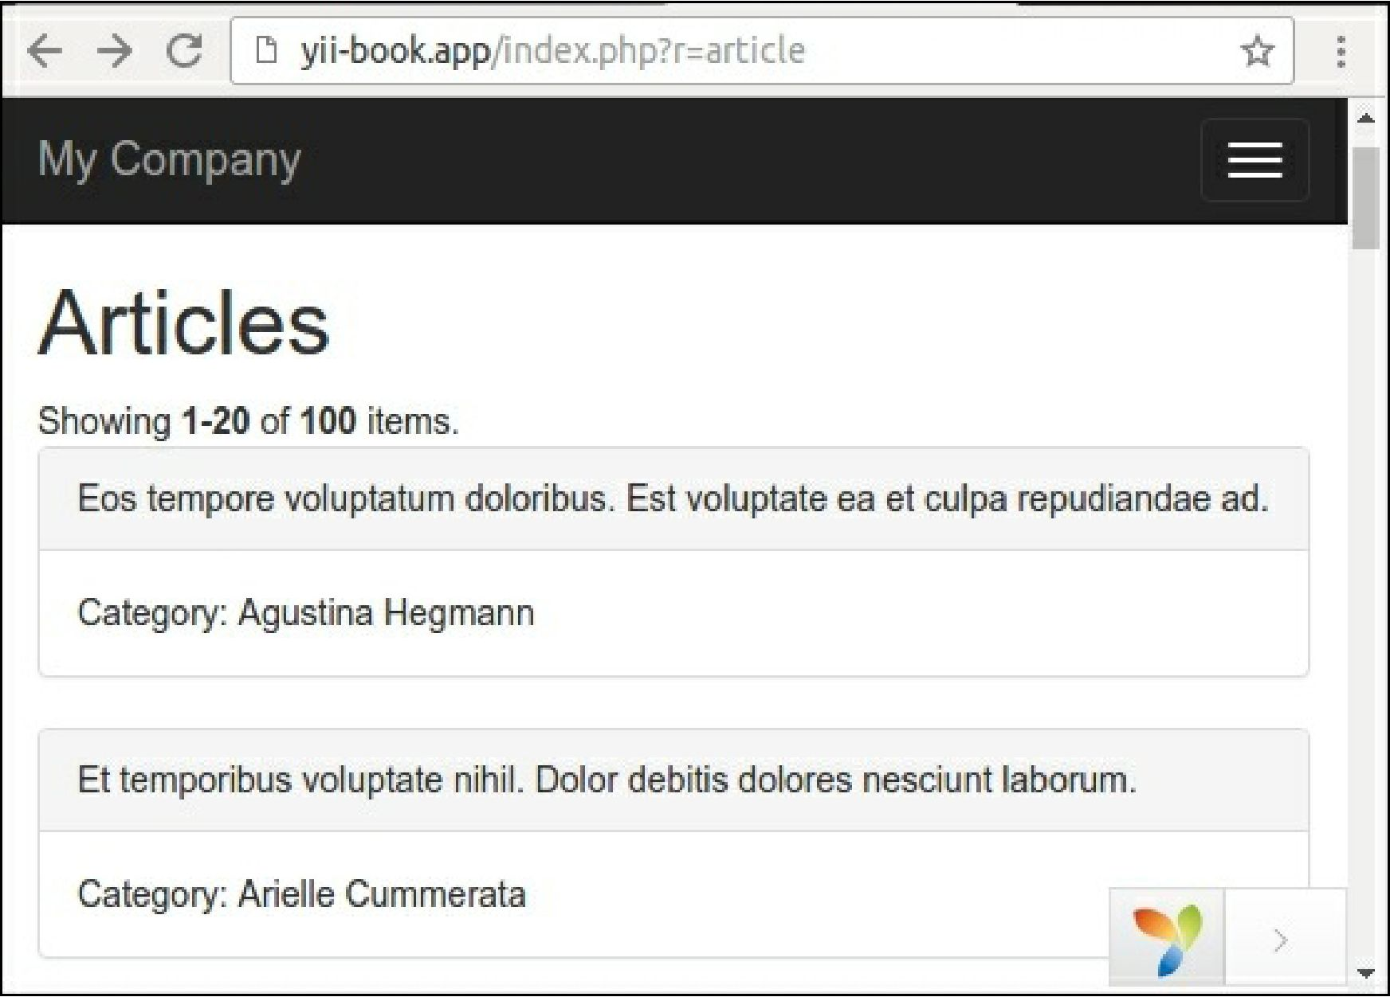

<div class="article-index">

<h1><?= Html::encode($this->title) ?></h1>

<?php Yii::beginProfile('articles') ?>

<?= ListView::widget([

'dataProvider' => $dataProvider,

'itemOptions' => ['class' => 'item'],

'itemView' => '_item',

]) ?>

<?php Yii::endProfile('articles') ?>

</div>

Now refresh the page.

1. Expand the debug panel at the bottom of page and click on the timing badge (73 ms in our case):

Log

Time

73 ms

Memory

3.572 MB

DB